SESSION : 22

Q1):
Sign up for a free Jira account (cloud version), create a new project using the Scrum template, and take a screenshot of your empty Scrum board.
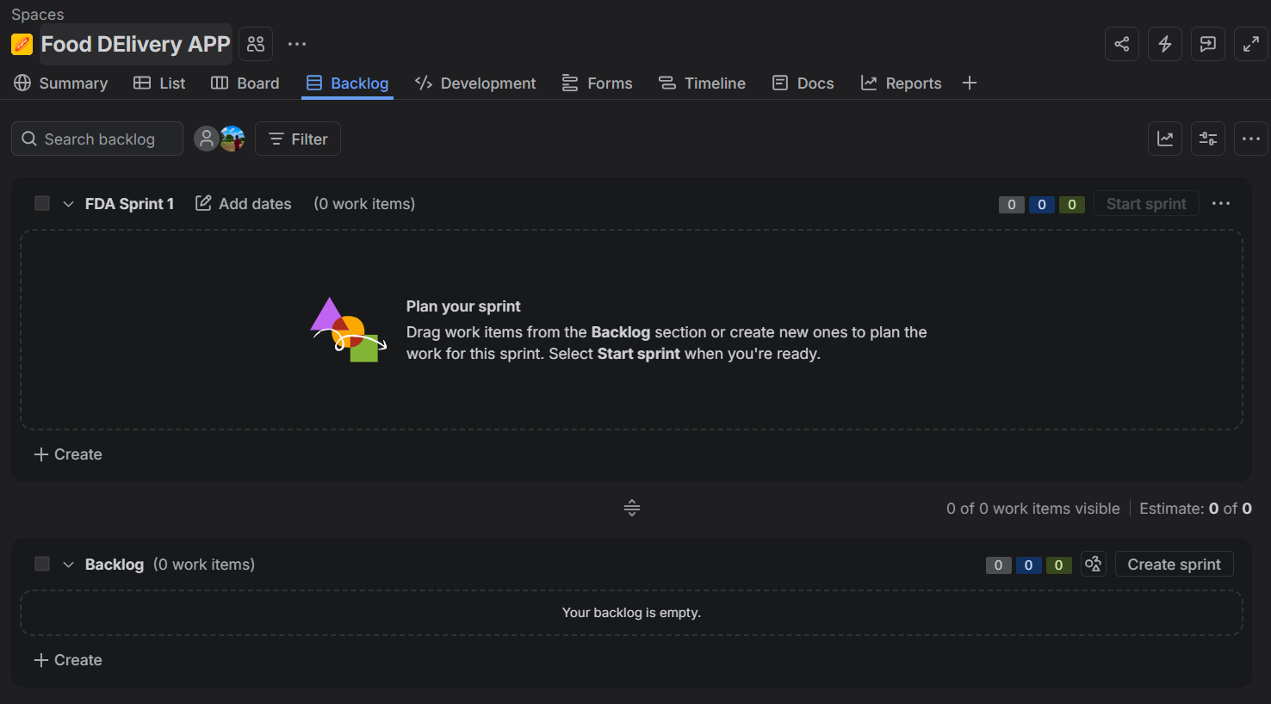

Jira Scrum Board Setup — Food Delivery App
Epics, Stories, Sub-tasks, Workflow, and Issue Types — Zomato / Swiggy-style project

2. Epic and User Stories
Epic: "Food Delivery App Features"
Three user stories were created under this epic:
- As a user, I want to search for restaurants
- As a user, I want to track my order in real-time
- As a user, I want to pay using UPI
Each story was linked to the epic via the "Epic Link" field (or the parent field on team-managed boards), so all three appear grouped under the epic in the backlog and on the Epic panel.

3. Sub-tasks Under "Search for Restaurants"
Under the story
"As a user, I want to search for restaurants"
the following two sub-tasks were added:
- Design search UI — covers wireframes and UI components for the search bar, filters, and results list.
- Integrate restaurant API — covers connecting the frontend to the backend restaurant/search service and handling response data.
Sub-tasks were created directly from the parent story using "Add > Sub-task", which keeps them nested under the story on the board and in the backlog.

4. Moving a Sub-task Through the Workflow
The sub-task "Design search UI" was moved across the board using drag-and-drop:
- To Do → In Progress: the card was dragged into the "In Progress" column once work began, which updated its status field automatically.
- In Progress → Done: after the UI design was completed, the card was dragged into the "Done" column, marking the sub-task as resolved.
Each drag updates the issue's status transition in real time, and the change is reflected on the parent story's progress bar (e.g., "1 of 2 sub-tasks done").

5. Jira Issue Types — Sample Issues
Jira's default classic workflow supports four core issue types. One sample issue of each type was created in the project. The table below lists the sample issue and explains when that issue type would be used in a real food-delivery app like Zomato or Swiggy.
Issue Type | Sample Issue Created | When to Use It (Zomato/Swiggy-style app)
Epic | "Food Delivery App Features" | Use an Epic for a large, multi-sprint body of work that groups related stories, such as the entire restaurant discovery experience or the entire payments overhaul.
Story | "As a user, I want to pay using UPI" | Use a Story to capture a specific, user-facing feature or requirement delivered in one or two sprints, like adding a new payment method or a live order-tracking map.
Task | "Set up push notification service for order updates" | Use a Task for technical or operational work that isn't tied to a specific user story, such as configuring infrastructure, writing documentation, or setting up a third-party SDK.
Bug | "App crashes when applying a coupon code at checkout" | Use a Bug to track a defect in existing functionality, such as an incorrect delivery-fee calculation or a restaurant menu that fails to load, so it can be triaged and fixed separately from new feature work.

Summary of Issue Hierarchy
In practice, these four types form a hierarchy on the Scrum board:
- Epic — the big initiative (e.g., "Food Delivery App Features")
  - Story — a user-facing feature within the epic (e.g., "Search for restaurants")
  - Task — standalone technical work, may or may not sit under an epic
  - Bug — a defect, can be linked to the story/epic it affects
  - Sub-task — a smaller unit of work under a Story, Task, or Bug (e.g., "Design search UI")

Note: Exact field names (e.g., "Epic Link" vs. "Parent") and available transitions depend on whether the Jira project uses a team-managed or company-managed Scrum board, and on the workflow configured for the project.

